> datos<-read.table("C:/Documents and Settings/Leticia/Mis documentos/ESPE/multivariado/semestre2013-1/datos/trespopulationaction2012.txt", header = TRUE,sep="")
> dim(datos)
> mydata<-datos[,2:12]
> attach(mydata)
> rownames(mydata)<-datos$Country
> ###los -99 los hago valores faltantes
> mydata$GNIpercapita2005[GNIpercapita2005<0]<-NA
> ###hacer imputacion multiple
> library(mice)
> imputados<-mice(mydata)
> completados<-(complete(imputados))###nueva base completada
>
> mydata2<-data.frame(lnpobl=log(completados$Totpop2005),lnPopages0.29_2005=log(completados$Popages0.29_2005),
+ lnPopages60._2005=log(completados$Popges60._2005),completados[,4:10],lnGNI=log(completados$GNIpercapita2005))
>
> attach(mydata2)
> rownames(mydata2)<-datos$Country
> plot(lnPopages0.29_2005,lnPopages60._2005,col=mydata2[,4])
> plot(lnPopages60._2005,lnPopages0.29_2005,col=mydata2[,4])
> #plot( lnPopages0.29_2005,col=mydata2[,4])
La componente 2 da el tamaño de población
#modelo con todas las variables
> modelo1<-princomp(mydata2,cor=TRUE)
> screeplot(modelo1)
La componente se forma de contrastes
> biplot(modelo1)
> loadings(modelo1)

Loadings:
Comp.1 Comp.2 Comp.3 Comp.4 Comp.5 Comp.6 Comp.7 Comp.8 Comp.9 Comp.10 Comp.11
lnpobl 0.935 -0.272 0.188 0.123
lnPopages0.29_2005 0.333 -0.233 0.261 -0.241 -0.189 0.146 0.362 -0.714
lnPopages60._2005 -0.315 0.129 0.314 -0.124 -0.263 0.264 -0.760 -0.155 0.146
Agestructure2005 -0.333 -0.457 0.332 0.512 -0.538
Agestructure1970 -0.266 0.144 0.635 -0.216 0.617 0.195 -0.119
Agestructure2025lowfert -0.324 -0.266 -0.173 -0.447 0.666 0.376
Agestructure2025medfert -0.328 -0.247 -0.247 -0.351 -0.301 -0.399 -0.554 -0.282
Agestructure2025highfert -0.333 -0.192 -0.166 -0.121 -0.120 0.119 -0.638 0.102 0.530 0.287
Totalfertrate2005.2010 0.324 0.303 0.146 -0.179 -0.226 0.177 -0.749 0.307
Infantmort2000.2005 0.306 0.235 0.274 -0.338 -0.449 -0.519 0.411 -0.121
lnGNI -0.293 0.172 0.805 -0.387 -0.104 0.198 -0.103

Comp.1 Comp.2 Comp.3 Comp.4 Comp.5 Comp.6 Comp.7 Comp.8 Comp.9 Comp.10 Comp.11
SS loadings 1.000 1.000 1.000 1.000 1.000 1.000 1.000 1.000 1.000 1.000 1.000
Proportion Var 0.091 0.091 0.091 0.091 0.091 0.091 0.091 0.091 0.091 0.091 0.091
Cumulative Var 0.091 0.182 0.273 0.364 0.455 0.545 0.636 0.727 0.818 0.909 1.000
>
> plot(modelo1$scores[,1],modelo1$scores[,2],type = "n")
Los colores corresponden a la estructura de edad en 2005.
A la izquierda los mas viejos, a la derecha los mas jóvenes.
Arriba los más poblados abajo los menos poblados.
> text(modelo1$scores[,1],modelo1$scores[,2],col=Agestructure2005,labels=1:177)
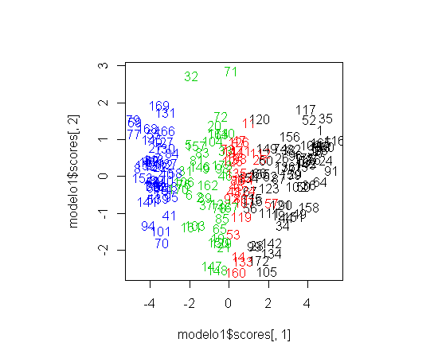
#Modelo 2 habiendo quitado varias variables de estructura de poblacion
> modelo2<-princomp(mydata2[,c(1:4,9:11)],cor=TRUE)
las cargas se interpretarían muy parecido al modelo 1
> screeplot(modelo2)
> biplot(modelo2)
> loadings(modelo2)

Loadings:
Comp.1 Comp.2 Comp.3 Comp.4 Comp.5 Comp.6 Comp.7
lnpobl 0.965 -0.209 -0.147
lnPopages0.29_2005 0.426 -0.334 -0.303 -0.772
lnPopages60._2005 -0.405 0.485 0.233 -0.659 0.220 -0.233
Agestructure2005 -0.427 0.131 0.200 0.650 -0.578
Totalfertrate2005.2010 0.406 0.471 -0.397 0.203 0.639
Infantmort2000.2005 0.394 0.193 0.601 0.117 -0.654
lnGNI -0.390 -0.103 -0.840 -0.328

Comp.1 Comp.2 Comp.3 Comp.4 Comp.5 Comp.6 Comp.7
SS loadings 1.000 1.000 1.000 1.000 1.000 1.000 1.000
Proportion Var 0.143 0.143 0.143 0.143 0.143 0.143 0.143
Cumulative Var 0.143 0.286 0.429 0.571 0.714 0.857 1.000
> summary(modelo2)
Importance of components:
Comp.1 Comp.2 Comp.3 Comp.4 Comp.5 Comp.6 Comp.7
Standard deviation 2.2386966 1.021911 0.63414901 0.54795948 0.34161160 0.2853097 0.208401107
Proportion of Variance 0.7159661 0.149186 0.05744928 0.04289423 0.01667121 0.0116288 0.006204432
Cumulative Proportion 0.7159661 0.865152 0.92260133 0.96549556 0.98216677 0.9937956 1.000000000
> plot(modelo2$scores[,1],modelo2$scores[,2],type = "n")
> text(modelo2$scores[,1],modelo2$scores[,2],col=Agestructure2005,labels=1:177)
> #text(modelo2$scores[,1],modelo2$scores[,2],col=Agestructure2025lowfert,Agestructure2005)
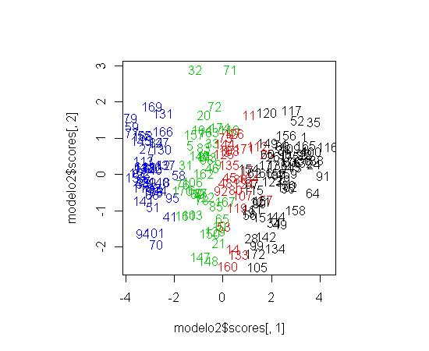
Muy parecido a la gráfica anterior, esta es usando los puntajes del modelo 2 que considera menos variables

#modelo sin considerer el tamanio d ela poblacion
> modelo3<-princomp(mydata2[,c(2:3,9:11)],cor=TRUE)
> screeplot(modelo3)
> biplot(modelo3)
> loadings(modelo3)

Loadings:
Comp.1 Comp.2 Comp.3 Comp.4 Comp.5
lnPopages0.29_2005 0.464 0.384 0.789
lnPopages60._2005 -0.444 -0.561 -0.270 -0.361 0.534
Totalfertrate2005.2010 0.449 -0.387 0.493 -0.606 -0.194
Infantmort2000.2005 0.441 -0.621 0.635 0.110
lnGNI -0.437 0.818 0.307 0.208

Comp.1 Comp.2 Comp.3 Comp.4 Comp.5
SS loadings 1.0 1.0 1.0 1.0 1.0
Proportion Var 0.2 0.2 0.2 0.2 0.2
Cumulative Var 0.2 0.4 0.6 0.8 1.0
> summary(modelo3)
Importance of components:
Comp.1 Comp.2 Comp.3 Comp.4 Comp.5
Standard deviation 2.0292032 0.64892130 0.54959937 0.28929851 0.27474084
Proportion of Variance 0.8235331 0.08421977 0.06041189 0.01673873 0.01509651
Cumulative Proportion 0.8235331 0.90775287 0.96816477 0.98490349 1.00000000
> plot(modelo3$scores[,1],modelo3$scores[,2],type = "n")
> text(modelo3$scores[,1],modelo3$scores[,2],col=Agestructure2005,labels=1:177)
> #text(modelo3$scores[,1],modelo3$scores[,2],col=Agestructure2025lowfert,Agestructure2005)
>
> plot(modelo3$scores[,1],modelo3$scores[,3],type = "n")
> text(modelo3$scores[,1],modelo3$scores[,3],col=Agestructure2005,labels=1:177)
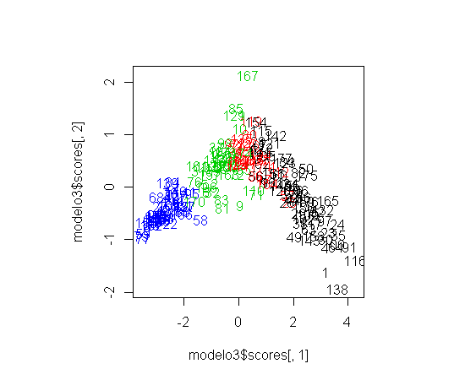
Los datos se enciman pues no se considera el tamanio de poblacion
#modelo como el anterior pero considrando el tamanio d ela poblacion

> modelo4<-princomp(mydata2[,c(1:3,9:11)],cor=TRUE)
> screeplot(modelo4)
> biplot(modelo4)
> loadings(modelo4)

Loadings:
Comp.1 Comp.2 Comp.3 Comp.4 Comp.5 Comp.6
lnpobl 0.970 -0.184 -0.145
lnPopages0.29_2005 0.465 -0.349 -0.143 -0.796
lnPopages60._2005 -0.445 0.115 0.511 0.361 -0.290 -0.560
Totalfertrate2005.2010 0.449 0.472 -0.411 -0.624 0.133
Infantmort2000.2005 0.440 0.172 0.573 0.135 0.654
lnGNI -0.436 0.180 -0.801 0.310 -0.183

Comp.1 Comp.2 Comp.3 Comp.4 Comp.5 Comp.6
SS loadings 1.000 1.000 1.000 1.000 1.000 1.000
Proportion Var 0.167 0.167 0.167 0.167 0.167 0.167
Cumulative Var 0.167 0.333 0.500 0.667 0.833 1.000
> summary(modelo4)
Importance of components:
Comp.1 Comp.2 Comp.3 Comp.4 Comp.5 Comp.6
Standard deviation 2.0295561 1.0192475 0.62935716 0.53777479 0.28544522 0.27434560
Proportion of Variance 0.6865163 0.1731442 0.06601507 0.04820029 0.01357983 0.01254425
Cumulative Proportion 0.6865163 0.8596606 0.92567563 0.97387592 0.98745575 1.00000000
> plot(modelo4$scores[,1],modelo4$scores[,2],type = "n")
> text(modelo4$scores[,1],modelo4$scores[,2],col=Agestructure2005,labels=1:177)
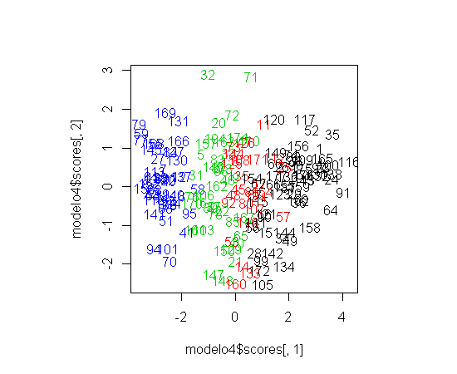
Este grafico es muy parecido con el gráfico del modelo 1.

