> hc <- hclust(dist(USArrests), "ave")
> plot(hc)
> plot(hc, hang = -1)
> (x <- identify(hc)) ## Terminate with 2nd mouse button !!
[[1]]
Alabama Alaska Arizona California Delaware Florida Illinois Louisiana Maryland Michigan
1 2 3 5 8 9 13 18 20 22
Mississippi Nevada New Mexico New York North Carolina South Carolina
24 28 31 32 33 40

> hc <- hclust(dist(USArrests)^2, "cen")
> memb <- cutree(hc, k = 10)
> cent <- NULL
> for(k in 1:10){
+ cent <- rbind(cent, colMeans(USArrests[memb == k, , drop = FALSE]))
+ }
> hc1 <- hclust(dist(cent)^2, method = "cen", members = table(memb))
> opar <- par(mfrow = c(1, 2))
> plot(hc, labels = FALSE, hang = -1, main = "Original Tree")
> plot(hc1, labels = FALSE, hang = -1, main = "Re-start from 10 clusters")
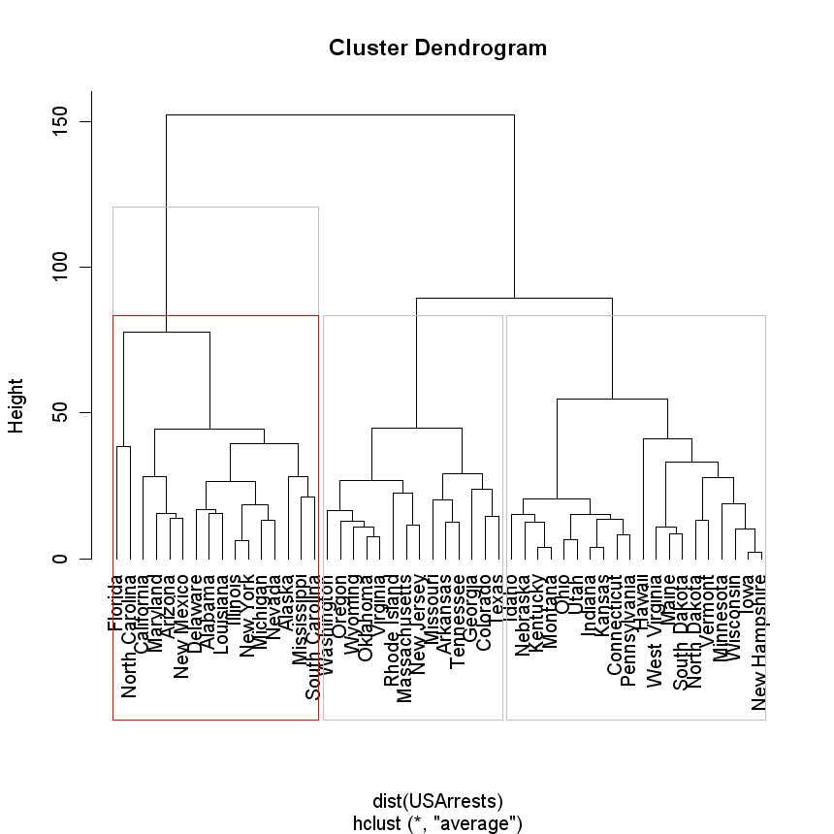
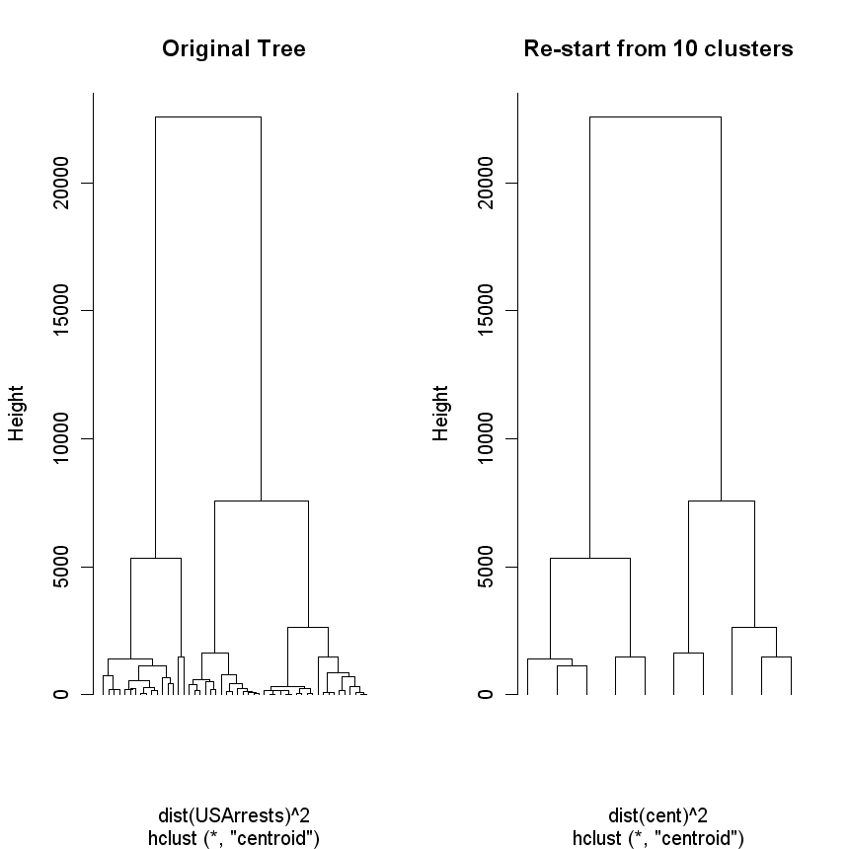

> cbind(memb,usarrets.kmeans$cluster)
Alabama 1 2
Alaska 1 2
Arizona 1 2
Arkansas 2 3
California 1 2
Colorado 2 3
Connecticut 3 1
Delaware 1 2
Florida 1 2
Georgia 2 3
Hawaii 3 1
Idaho 3 1
Illinois 1 2
Indiana 3 1
Iowa 3 1
Kansas 3 1
Kentucky 3 1
Louisiana 1 2
Maine 3 1
Maryland 1 2
Massachusetts 2 3
Michigan 1 2
Minnesota 3 1
Mississippi 1 2
Missouri 2 3
Montana 3 1
Nebraska 3 1
Nevada 1 2
New Hampshire 3 1
New Jersey 2 3
New Mexico 1 2
New York 1 2
North Carolina 1 2
North Dakota 3 1
Ohio 3 1
Oklahoma 2 3
Oregon 2 3
Pennsylvania 3 1
Rhode Island 2 3
South Carolina 1 2
South Dakota 3 1
Tennessee 2 3
Texas 2 3
Utah 3 1
Vermont 3 1
Virginia 2 3
Washington 2 3
West Virginia 3 1
Wisconsin 3 1
Wyoming 2 3

