DOS EJEMPLOS DE ANALISIS DE FACTORES

1. Este es un ejemplo construido.
Se miden seis carácterísticas a n=18 sujetos, pero en realidad… v2 es una variacion de v1 y v4 de v3 y v6 de v5. es decir en realidad hay solo tres Esto se ve muy claro en las gráficas
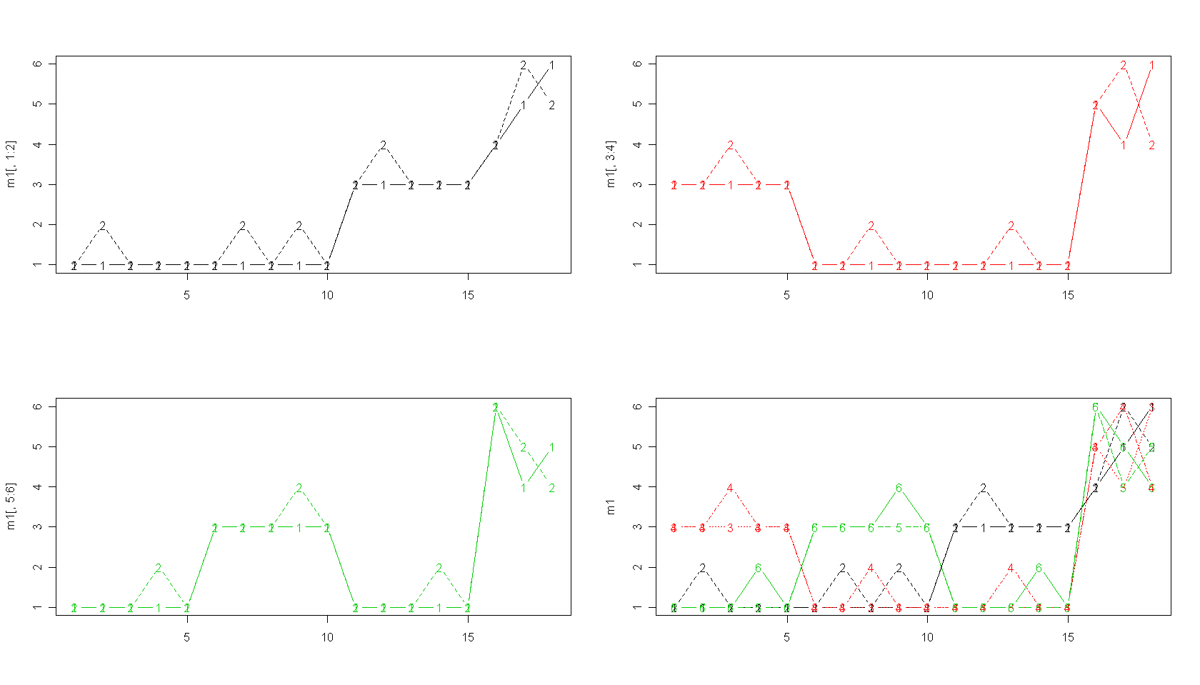

> # A little demonstration, v2 is just v1 with noise,
> # and same for v4 vs. v3 and v6 vs. v5
> # Last four cases are there to add noise
> # and introduce a positive manifold (g factor)
> v1 <- c(1,1,1,1,1,1,1,1,1,1,3,3,3,3,3,4,5,6)
> v2 <- c(1,2,1,1,1,1,2,1,2,1,3,4,3,3,3,4,6,5)
> v3 <- c(3,3,3,3,3,1,1,1,1,1,1,1,1,1,1,5,4,6)
> v4 <- c(3,3,4,3,3,1,1,2,1,1,1,1,2,1,1,5,6,4)
> v5 <- c(1,1,1,1,1,3,3,3,3,3,1,1,1,1,1,6,4,5)
> v6 <- c(1,1,1,2,1,3,3,3,4,3,1,1,1,2,1,6,5,4)
> m1 <- cbind(v1,v2,v3,v4,v5,v6)
>
> par(mfrow=c(2,2))
> matplot(m1[,1:2],col=c(1,1),type="b")
> matplot(m1[,3:4],col=c(2,2),type="b")
> matplot(m1[,5:6],col=c(3,3),type="b")
> matplot(m1,type="b",col=c(1,1,2,2,3,3))
> par(mfrow=c(1,1))
> cor(m1)
v1 v2 v3 v4 v5 v6
Correlaciones altas
v1 1.0000000 0.9393083 0.5128866 0.4320310 0.4664948 0.4086076
v2 0.9393083 1.0000000 0.4124441 0.4084281 0.4363925 0.4326113
v3 0.5128866 0.4124441 1.0000000 0.8770750 0.5128866 0.4320310
v4 0.4320310 0.4084281 0.8770750 1.0000000 0.4320310 0.4323259
v5 0.4664948 0.4363925 0.5128866 0.4320310 1.0000000 0.9473451
v6 0.4086076 0.4326113 0.4320310 0.4323259 0.9473451 1.0000000
> factanal(m1, factors=3) # varimax is the default
Máximo número de factores
Call:
factanal(x = m1, factors = 3)

Uniquenesses:
v1 v2 v3 v4 v5 v6
0.005 0.101 0.005 0.224 0.084 0.005

Loadings:
Factor1 Factor2 Factor3
Estas cargas ya están rotadas con varimax
v1 0.944 0.182 0.267
v2 0.905 0.235 0.159
v3 0.236 0.210 0.946
v4 0.180 0.242 0.828
v5 0.242 0.881 0.286
v6 0.193 0.959 0.196

Factor1 Factor2 Factor3
SS loadings 1.893 1.886 1.797
Proportion Var 0.316 0.314 0.300
Cumulative Var 0.316 0.630 0.929

The degrees of freedom for the model is 0 and the fit was 0.4755

> factanal(m1, factors=3, rotation="promax")

Call:
factanal(x = m1, factors = 3, rotation = "promax")
Uniquenesses:
unicidades
v1 v2 v3 v4 v5 v6
0.005 0.101 0.005 0.224 0.084 0.005
Estas son las cargas con rotación oblicua.
Y es la rotación que mejor reproduce la situación original
Loadings:
Factor1 Factor2 Factor3
v1 0.985
v2 0.951
v3 1.003
v4 0.867
v5 0.910
v6 1.033
Factor1 Factor2 Factor3
SS loadings 1.903 1.876 1.772
Proportion Var 0.317 0.313 0.295
Cumulative Var 0.317 0.630 0.925
The degrees of freedom for the model is 0 and the fit was 0.4755

> # The following shows the g factor as PC1
> prcomp(m1)
Standard deviations:
[1] 3.0368683 1.6313757 1.5818857 0.6344131 0.3190765 0.2649086
Los cp no se parecen a los factores
Rotation:
PC1 PC2 PC3 PC4 PC5 PC6
v1 0.4168038 -0.52292304 0.2354298 -0.2686501 0.5157193 -0.39907358
v2 0.3885610 -0.50887673 0.2985906 0.3060519 -0.5061522 0.38865228
v3 0.4182779 0.01521834 -0.5555132 -0.5686880 -0.4308467 -0.08474731
v4 0.3943646 0.02184360 -0.5986150 0.5922259 0.3558110 0.09124977
v5 0.4254013 0.47017231 0.2923345 -0.2789775 0.3060409 0.58397162
v6 0.4047824 0.49580764 0.3209708 0.2866938 -0.2682391 -0.57719858

> ## formula interface
Aquí se usa fórmula en el llamado de la función.
> factanal(~v1+v2+v3+v4+v5+v6, factors = 3,
+ scores = "Bartlett")$scores
Factor1 Factor2 Factor3
Estos serían los valores que toma cada factor en los 18 sujetos. Usando el método de Bartlett para estimarlos.
1 -0.9039949 -0.9308984 0.9475392
2 -0.8685952 -0.9328721 0.9352330
3 -0.9082818 -0.9320093 0.9616422
4 -1.0021975 -0.2529689 0.8178552
5 -0.9039949 -0.9308984 0.9475392
6 -0.7452711 0.7273960 -0.7884733
7 -0.7098714 0.7254223 -0.8007795
8 -0.7495580 0.7262851 -0.7743704
9 -0.8080740 1.4033517 -0.9304636
10 -0.7452711 0.7273960 -0.7884733
11 0.9272282 -0.9307506 -0.8371538
12 0.9626279 -0.9327243 -0.8494600
13 0.9229413 -0.9318615 -0.8230509
14 0.8290256 -0.2528211 -0.9668378
15 0.9272282 -0.9307506 -0.8371538
16 0.4224366 2.0453079 1.2864761
17 1.4713902 1.2947716 0.5451562
18 1.8822320 0.3086244 1.9547752
Y si se usa el método de regresión son estos otros, como ven, son parecidos

> ### otra opcion de calcular los scores
> factanal(m1, factors = 3,
+ scores = "regression")$scores
Factor1 Factor2 Factor3
[1,] -0.8965113 -0.9246889 0.9363764
[2,] -0.8613962 -0.9266171 0.9242550
[3,] -0.9007301 -0.9257723 0.9503640
[4,] -0.9933051 -0.2514130 0.8086594
[5,] -0.8965113 -0.9246889 0.9363764
[6,] -0.7411512 0.7201081 -0.7835330
[7,] -0.7060361 0.7181799 -0.7956543
[8,] -0.7453700 0.7190246 -0.7695453
[9,] -0.8028298 1.3914557 -0.9233713
[10,] -0.7411512 0.7201081 -0.7835330
[11,] 0.9168926 -0.9250562 -0.8303339
[12,] 0.9520078 -0.9269844 -0.8424553
[13,] 0.9126739 -0.9261397 -0.8163463
[14,] 0.8200989 -0.2517803 -0.9580509
[15,] 0.9168926 -0.9250562 -0.8303339
[16,] 0.4264536 2.0356890 1.2824424
[17,] 1.4647876 1.2901018 0.5479527
[18,] 1.8751853 0.3135297 1.9467308

> ### de donde salen algunas cantidades
> r1<-c( 0.944 , 0.182 , 0.267 )
Guardo las cargas en una matriz del primer análisis
> r2<-c( 0.905 , 0.235 , 0.159 )
> r3<-c( 0.236 , 0.210 , 0.946 )
> r4<-c( 0.180 , 0.242 , 0.828 )
> r5<-c( 0.242 , 0.881 , 0.286)
> r6<-c( 0.193 , 0.959 , 0.196)
> mm<-matrix(c(r1,r2,r3,r4,r5,r6),ncol=3,byrow=T)
> mm
[,1] [,2] [,3]
[1,] 0.944 0.182 0.267
[2,] 0.905 0.235 0.159
[3,] 0.236 0.210 0.946
[4,] 0.180 0.242 0.828
Las elevo al cuadrado
[5,] 0.242 0.881 0.286
[6,] 0.193 0.959 0.196
> mm^2
[,1] [,2] [,3]
[1,] 0.891136 0.033124 0.071289
[2,] 0.819025 0.055225 0.025281
[3,] 0.055696 0.044100 0.894916
[4,] 0.032400 0.058564 0.685584
[5,] 0.058564 0.776161 0.081796
Las sumo por columna, coincide con
SS loadings
[6,] 0.037249 0.919681 0.038416
> ## SS loadings es igual a:
> apply(mm^2,2,sum)
Calculo la comunalidad (por renglón) para cada vi y si a 1(=varianza) le resto la comunalidad me da la unicidad.
[1] 1.894070 1.886855 1.797282
>
> ## Uniquenesses
> 1-apply(mm^2,1,sum)
[1] 0.004451 0.100469 0.005288 0.223452 0.083479 0.004654
>
2. Ejemplo con datos de habilidad.

The tests are described as
general:
a non-verbal measure of general intelligence using Cattell's culture-fair test.
picture:
a picture-completion test
blocks:
block design
maze:
mazes
reading:
reading comprehension
vocab:
vocabulary

> example(ability.cov)
ablty.> require(stats)
[1] TRUE
ablty.> (ability.FA <- factanal(factors = 1, covmat=ability.cov))
Call:
Las unicidades son muy altas, el modelo se ve no será bueno
factanal(factors = 1, covmat = ability.cov)

Uniquenesses:
general picture blocks maze reading vocab
0.535 0.853 0.748 0.910 0.232 0.280
Loadings:
Factor1
general 0.682
picture 0.384
blocks 0.502
maze 0.300
reading 0.877
vocab 0.849
Factor1
SS loadings 2.443
Proportion Var 0.407
La prueba Ho: R=modelo es de un factor. H1 no es ese modelo de 1 factor.
Test of the hypothesis that 1 factor is sufficient.
The chi square statistic is 75.18 on 9 degrees of freedom.
The p-value is 1.46e-12

ablty.> update(ability.FA, factors=2)
Call:
factanal(factors = 2, covmat = ability.cov)
Este modelo es mejor que el anterior.
.
Uniquenesses:
general picture blocks maze reading vocab
0.455 0.589 0.218 0.769 0.052 0.334

Loadings:
Factor1 Factor2
general 0.499 0.543
picture 0.156 0.622
blocks 0.206 0.860
maze 0.109 0.468
La prueba Ho: R=modelo de dos factores. H1: R no es ese modelo. La ji cuadrada es pequeña, parecida a los grados de libertad, el p-value > 0.10, entonces este modelo (2 factores) no se rechaza.
reading 0.956 0.182
vocab 0.785 0.225

Factor1 Factor2
SS loadings 1.858 1.724
Proportion Var 0.310 0.287
Cumulative Var 0.310 0.597

Test of the hypothesis that 2 factors are sufficient.
The chi square statistic is 6.11 on 4 degrees of freedom.
The p-value is 0.191

ablty.> update(ability.FA, factors=2, rotation="promax")

Call:
factanal(factors = 2, covmat = ability.cov, rotation = "promax")

Uniquenesses:
general picture blocks maze reading vocab
0.455 0.589 0.218 0.769 0.052 0.334
Quedan dos factores: F1 habilidad con palabra, F2 habilidad con figuras. No cambian las unicidades
Las unicidades no cambian con la rotación Las unicidades no cambian con la rotación

Loadings:
Factor1 Factor2
general 0.364 0.470
picture 0.671
blocks 0.932
maze 0.508
La proporción de variancion total explicada no coincide por errores de redondeo.
reading 1.023
vocab 0.811

Factor1 Factor2
Es la misma que la de arriba.
SS loadings 1.853 1.807
Proportion Var 0.309 0.301
Cumulative Var 0.309 0.610

Test of the hypothesis that 2 factors are sufficient.
The chi square statistic is 6.11 on 4 degrees of freedom.
The p-value is 0.191

