Ejemplos de Cluster
> USArrests
Murder Assault UrbanPop Rape
Alabama 13.2 236 58 21.2
Alaska 10.0 263 48 44.5
Arizona 8.1 294 80 31.0
Arkansas 8.8 190 50 19.5
…
Wisconsin 2.6 53 66 10.8
Wyoming 6.8 161 60 15.6
> hc <- hclust(dist(USArrests), "ave")
> plot(hc)
> plot(hc, hang = -1)
> (x <- identify(hc))
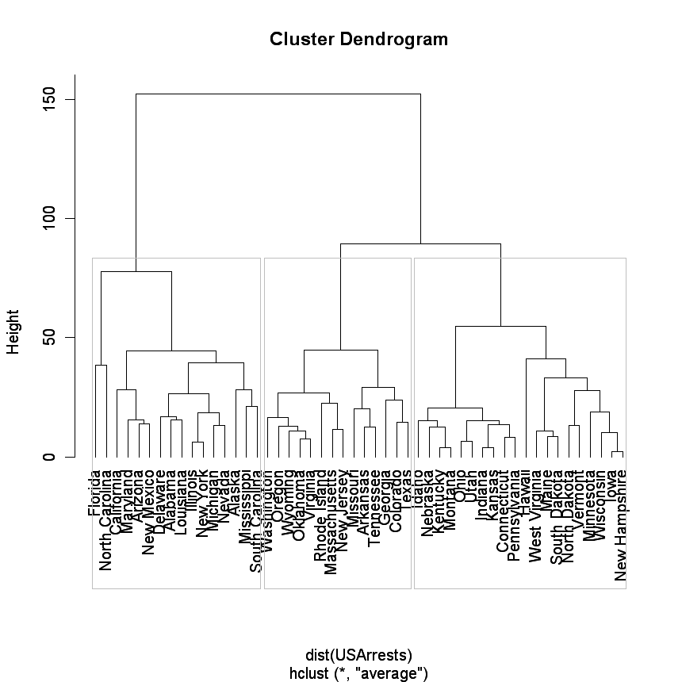
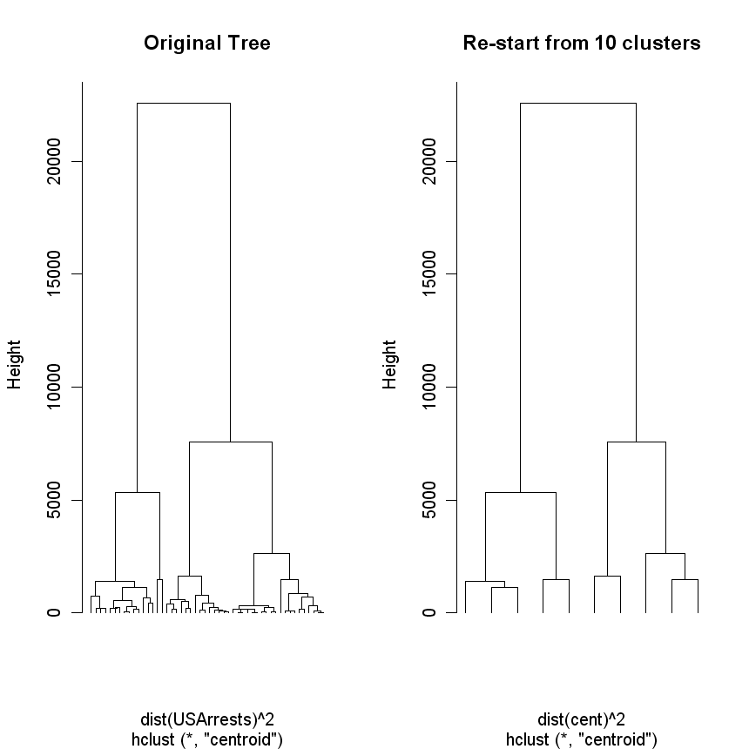

[[1]]
Alabama Alaska Arizona California Delaware Florida Illinois Louisiana Maryland Michigan
1 2 3 5 8 9 13 18 20 22
Mississippi Nevada New Mexico New York North Carolina South Carolina
24 28 31 32 33 40

[[2]]
Arkansas Colorado Georgia Massachusetts Missouri New Jersey Oklahoma Oregon Rhode Island Tennessee Texas
4 6 10 21 25 30 36 37 39 42 43
Virginia Washington Wyoming
46 47 50

[[3]]
Connecticut Hawaii Idaho Indiana Iowa Kansas Kentucky Maine Minnesota Montana Nebraska
7 11 12 14 15 16 17 19 23 26 27
New Hampshire North Dakota Ohio Pennsylvania South Dakota Utah Vermont West Virginia Wisconsin
29 34 35 38 41 44 45 48 49

> hc <- hclust(dist(USArrests)^2, "cen")
> memb <- cutree(hc, k = 10)
> memb
Alabama Alaska Arizona Arkansas California Colorado Connecticut Delaware Florida Georgia
1 2 3 4 3 4 5 1 6 4
Hawaii Idaho Illinois Indiana Iowa Kansas Kentucky Louisiana Maine Maryland
7 5 1 5 8 5 5 1 8 3
Massachusetts Michigan Minnesota Mississippi Missouri Montana Nebraska Nevada New Hampshire New Jersey
9 1 8 2 4 5 5 1 8 9
New Mexico New York North Carolina North Dakota Ohio Oklahoma Oregon Pennsylvania Rhode Island South Carolina
3 1 10 8 5 9 9 5 9 2
South Dakota Tennessee Texas Utah Vermont Virginia Washington West Virginia Wisconsin Wyoming
8 4 4 5 8 9 9 8 8 9
> for(k in 1:10){
+ cent <- rbind(cent, colMeans(USArrests[memb == k, , drop = FALSE]))
+ }
> hc1 <- hclust(dist(cent)^2, method = "cen", members = table(memb))
> opar <- par(mfrow = c(1, 2))
> plot(hc, labels = FALSE, hang = -1, main = "Original Tree")
> plot(hc1, labels = FALSE, hang = -1, main = "Re-start from 10 clusters")

