Ejercicio
There are 62 data points (tracks),
11 tracks from Abba, Beatles,
10 tracks from Eels,
8 tracks from Beethoven
6 tracks from Mozart,
13 tracks from Vivaldi and
3 tracks from Enya.
The variables are:
LVar, LAve, LMax the variance, average, maximum of the frequencies of the left channels
LFEner an indicator of the amplitude or loudness of thesound.
LFreq an average of the most common frequencies computed using the periodogram function.

> music[,1:2]
Artist Type
Dancing Queen Abba Rock
Knowing Me Abba Rock
Take a Chance Abba Rock
Mamma Mia Abba Rock
Lay All You Abba Rock
Super Trouper Abba Rock
I Have A Dream Abba Rock
The Winner Abba Rock
Money Abba Rock
SOS Abba Rock
V1 Vivaldi Classical
V2 Vivaldi Classical
V3 Vivaldi Classical
V4 Vivaldi Classical
V5 Vivaldi Classical
V6 Vivaldi Classical
V7 Vivaldi Classical
V8 Vivaldi Classical
V9 Vivaldi Classical
V10 Vivaldi Classical
M1 Mozart Classical
M2 Mozart Classical
M3 Mozart Classical
M4 Mozart Classical
M5 Mozart Classical
M6 Mozart Classical
All in a Days Work Eels Rock
Saturday Morning Eels Rock
The Good Old Days Eels Rock
Love of the Loveless Eels Rock
Girl Eels Rock
Agony Eels Rock
Rock Hard Times Eels Rock
Restraining Eels Rock
Lone Wolf Eels Rock
Wrong About Bobby Eels Rock
Love Me Do Beatles Rock
I Want to Hold Your Hand Beatles Rock
Cant Buy Me Love Beatles Rock
I Feel Fine Beatles Rock
Ticket to Ride Beatles Rock
Help Beatles Rock
Yesterday Beatles Rock
Yellow Submarine Beatles Rock
Eleanor Rigby Beatles Rock
Penny Lane Beatles Rock
B1 Beethoven Classical
B2 Beethoven Classical
B3 Beethoven Classical
B4 Beethoven Classical
B5 Beethoven Classical
B6 Beethoven Classical
B7 Beethoven Classical
B8 Beethoven Classical
The Memory of Trees Enya New wave
Anywhere Is Enya New wave
Pax Deorum Enya New wave
1 <NA> <NA>
2 <NA> <NA>
3 <NA> <NA>
4 <NA> <NA>
5 <NA> <NA>

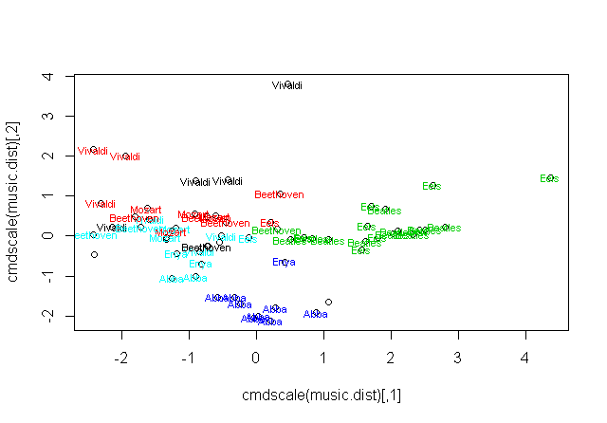cluster con Kmeans
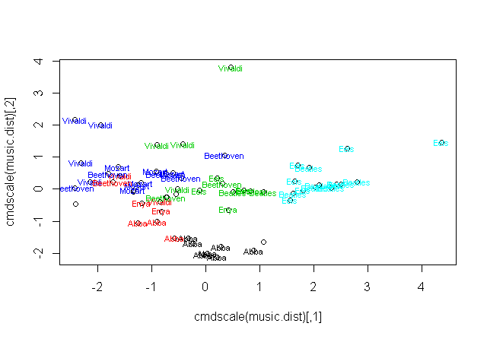cluster jerarquico con liga Ward
